Deployment Guidelines for Integral SSO-CAS5

Prepared by
DXC

Contents
1 General Information 3
1.1 Purpose 3
1.2 Softwares & Packages required 3
2 Setup OpenLDAP 3
2.1 Installation 3
2.2 Configuration 7
2.3 Start service 7
2.4 Import LDIF file and Verify 8
3 Setup CAS 5.1.4 9
3.1 Clone code 9
3.2 Update properties 10
3.2.1 Integral-cas-5x\src\main\resources\application.properties 10
3.2.2 Integral-cas-5x\src\main\resources\dxc-integral.properties 11
3.3 Build cas.war 11
3.4 Restore CAS5DB 11
3.5 Deploy cas.war 11
3.6 Verify 12
3.6.1 http://localhost:8080/cas/login 12
3.6.2 http:// localhost:8080/cas/pms 12

General Information

Purpose
The document is to guide how to setup Integral - SSO on Windows OS platform.

Softwares & Packages required
- Java version 8
- Tomcat 8
- Open LDAP

Setup OpenLDAP

Installation
  - Download open Ldap from http://www.userbooster.de/en/download/openldap-for-windows.aspx.

  - Click on next.

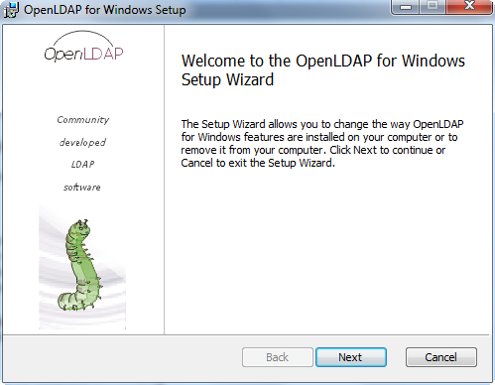

  - Accept the license agreement and click next.

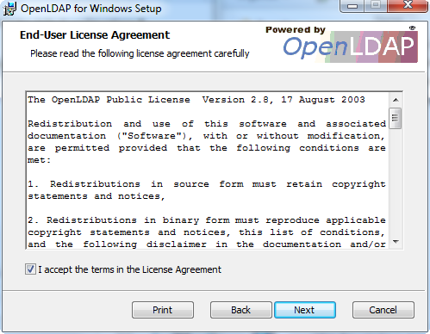

  - Choose the Installation Directory and click Next.

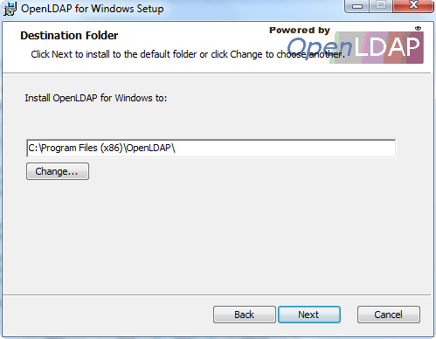

  - Click Next in the below window.

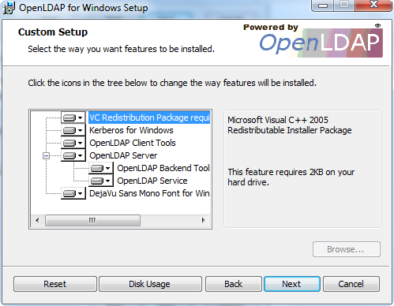
  - Choose the default settings and click next.

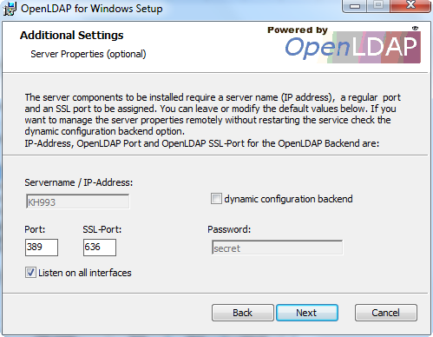

  - Select the backend for ldap as SQL.
In case of Integral, please select LDIF

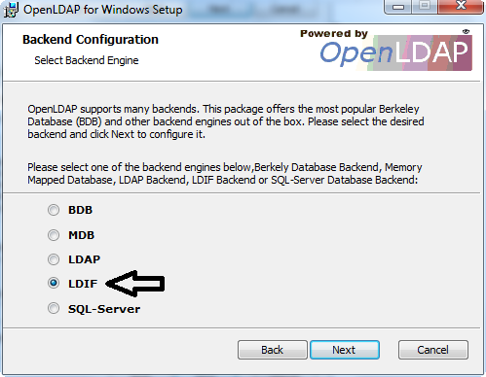

Configuration
After installed the OpenLDAP, update slapd.conf
(The path could be likely - C:\Program Files (x86)\OpenLDAP\slap.conf)
Items need to be cared:
- suffix "dc=dolphin,dc=com"
- rootdn "cn=Manager,dc=dolphin,dc=com"
- rootpw {SSHA}N2TeLOha6HVXgTUHg09XhmyXXPv9VT0d

Notes:
The root pass word is ‘Gu0ma0’. It was encoded.
# ldif database definitions
database ldif

Start service
Access services application in Windows
Start the OpenLDAP

Import LDIF file and Verify
You may need to download ApacheDrirectoryStudio for this step
Config connection to access the LDAP with Apache Studio
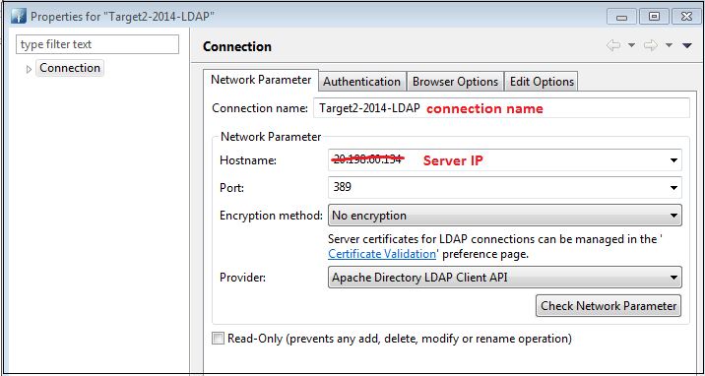
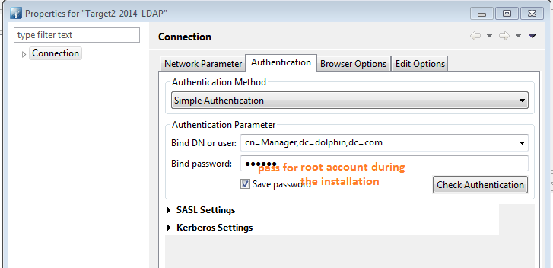

After connected to the LDAP server
Get the ldif file in the package and import the ldif file to the new system
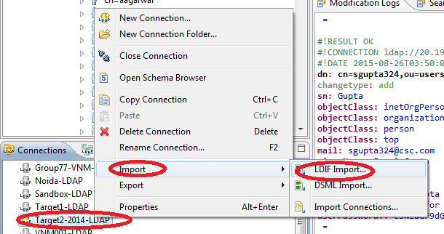

Import Integral-cas-5x \ldif\integral.ldif
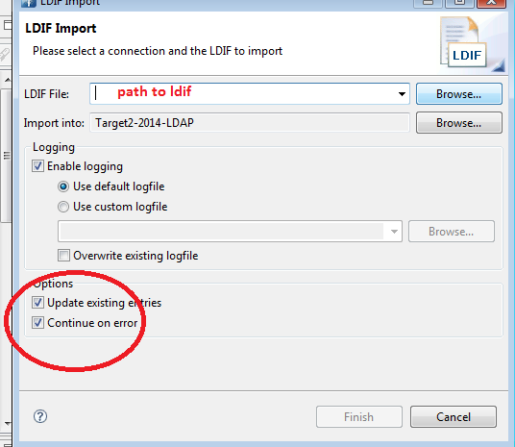

Setup CAS 5.1.4
Main Steps

Clone code
https://github.dxc.com/insurance/Integral-cas-5x

Update properties

Integral-cas-5x\src\main\resources\application.properties
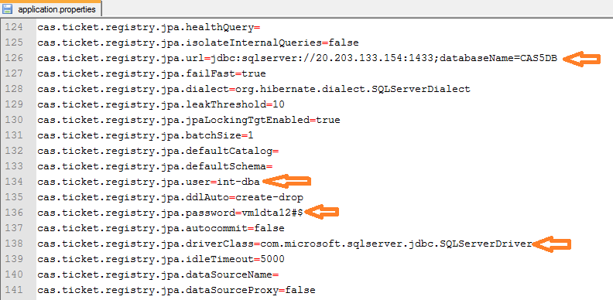

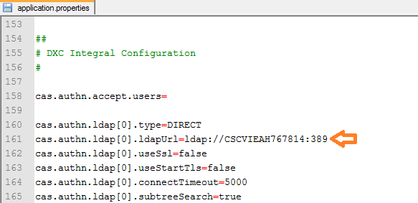

Integral-cas-5x\src\main\resources\dxc-integral.properties
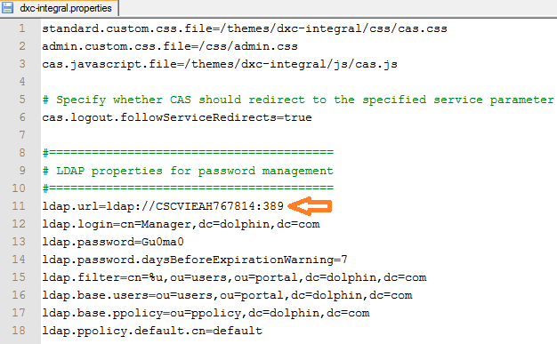

Build cas.war
Make war file by command: mvn clean install

Restore CAS5DB
- MSSQL
Get backup file at: Integral-cas-5x\database\MSSQL\CAS5DB.bak

Deploy cas.war
Copy the cas.war after configured into a webapps
Start tomcat: apache-tomcat\bin\startup.bat

Testing

http://localhost:8080/cas/login
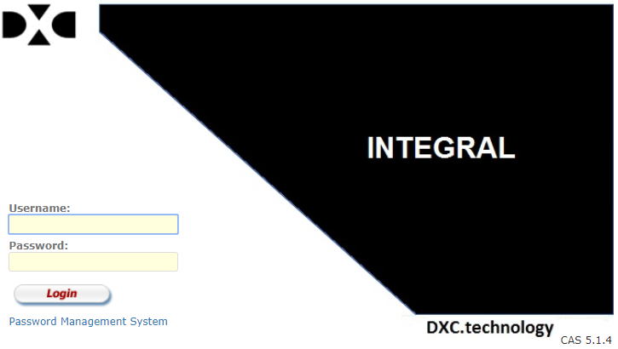

http:// localhost:8080/cas/pms
